**Company Name:** MY HOME GRUPO INMOBILIARIO.

**Contact Information:**

* Phone: (GDL) (33) 13-54-64-69 / (33) 32 30 33 12
* WhatsApp Business: (33) 32 30 33 12
* Email: ventasmyhome@gmail.com
* Address: Eulogio Parra 1851. Colonia Ladrón de Guevara, Guadalajara, Jalisco. Código Postal: 44600.
* Social Media: Soon To Come FB & IG.

**Ideal URL:** [https://www.myhomegrupoinmobiliario.com](https://www.myhomegrupoinmobiliario.com/)

**Example Website:** <https://www.alfaoccidente.com/> (Does not have to be the same; this is just an idea but we’re open to proposals and optimizations).

**Website Language:** Spanish (English is used only as an internal reference for us).

**Number and Name for Tabs:**

* Inicio (Home section)
* Vender (To Sell)
* Comprar (To Buy)
* Rentar (To Rent)
* Administración de propiedades (Real Estate Administration).
* Quiénes somos (Who We Are).
* Contacto (Contact).

**General Ideas From the Client:**

* To use the colors of the company logo, mainly blue (but open to other suggestions).

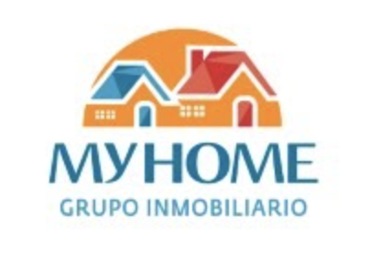

* There’s no professional photos provided by the client. We need to come up with ideas from a bank of images.

**WEBSITE SECTIONS**

(AS SUGGESTED BY THE CLIENT, WITH FLEXIBILITY)

1. **HOME**

* Inicio (Home Section): Add a banner that communicates the idea of a home- owning… Whatever makes the potential clients feel a warm yet professional feeling.
* In addition to the tabs, they’d like to have buttons (CTAs) on the home page, even if the info is repetitive. The buttons would be:
  + Quiero vender (I want to sell)
  + Quiero comprar (I want to buy)
  + Quiero rentar (I want to rent)
  + Quiero que administren mi propiedad (I want that you manage my property).
* In the same home page, add something that highlights the value of the company. Something like this. We can use the same values with different wording , or add things that might be attractive to the potential customers.



* In the same home page, below, we need a list of the highlighted properties: Photo, size, price, highlights. Then, the client would click that section and be launched to a new tab with the “Ficha técnica,” which is all the properties details (I’ll upload a folder with every document. We’re asked to please fix the aesthetics. We can’t upload the PDFs, we have to copy-paste the info and photos and arrange them in a nice way. I think there’s not a lot).
* In the same home page, below, we’d need a tool like the following Kris. Could you come up with this? I trust you! Hehe. It basically gives the page visitor’s the possibility of filtering the search. The first tab would be: Venta OR Compra OR Renta. The second tab would be: Casa OR Departamento. The third tab would be: Ingresa el código postal (Add Zip Code). Everything would be within the same state: Jalisco, México.
* In the same home page, below, we’d need some lifestyle photos (aspirational yet realistic).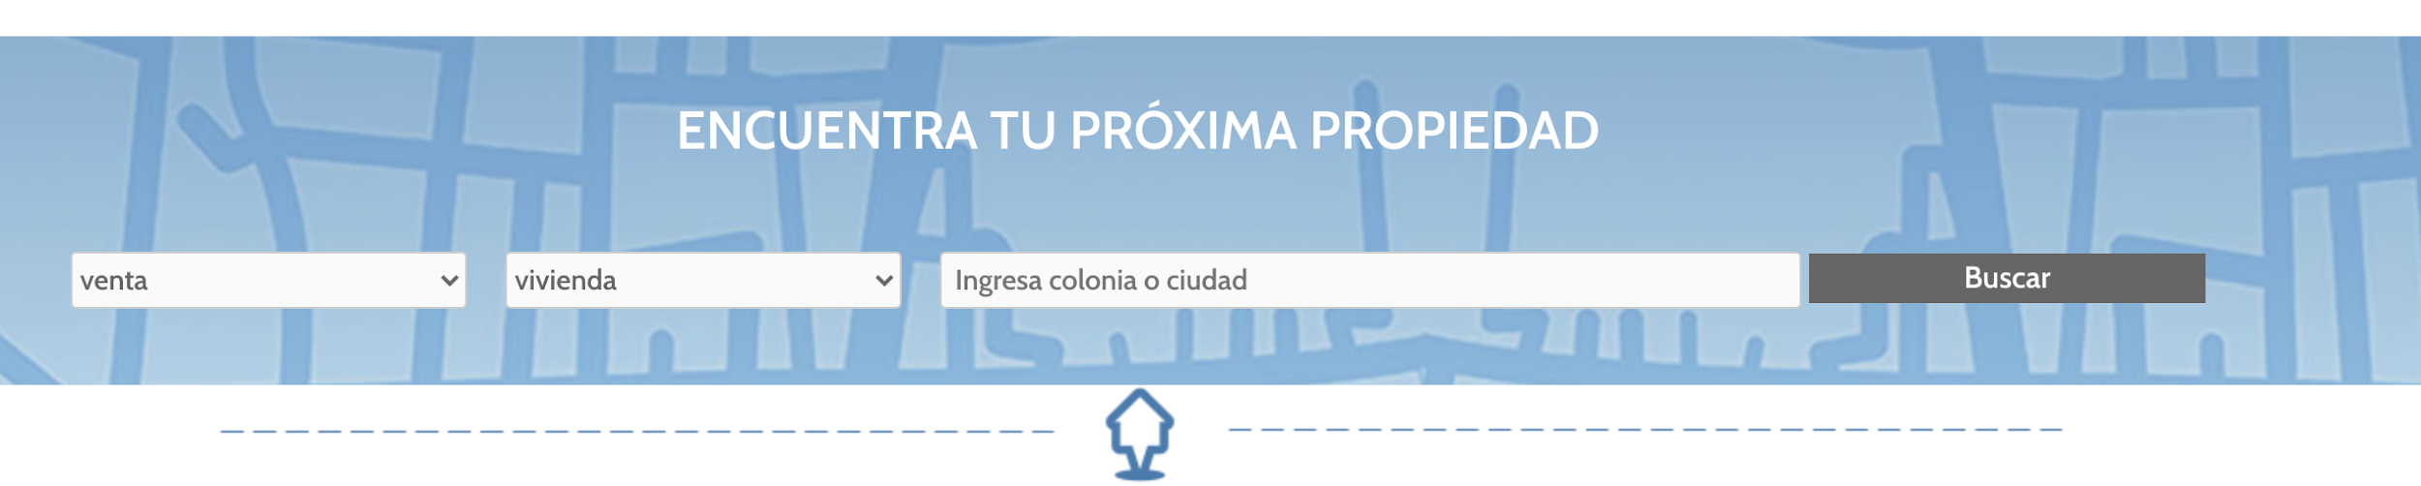
* At the very bottom of the home page, we’d have a Call To Action to Contact them. Something like the following example. I also asked them for client reviews.

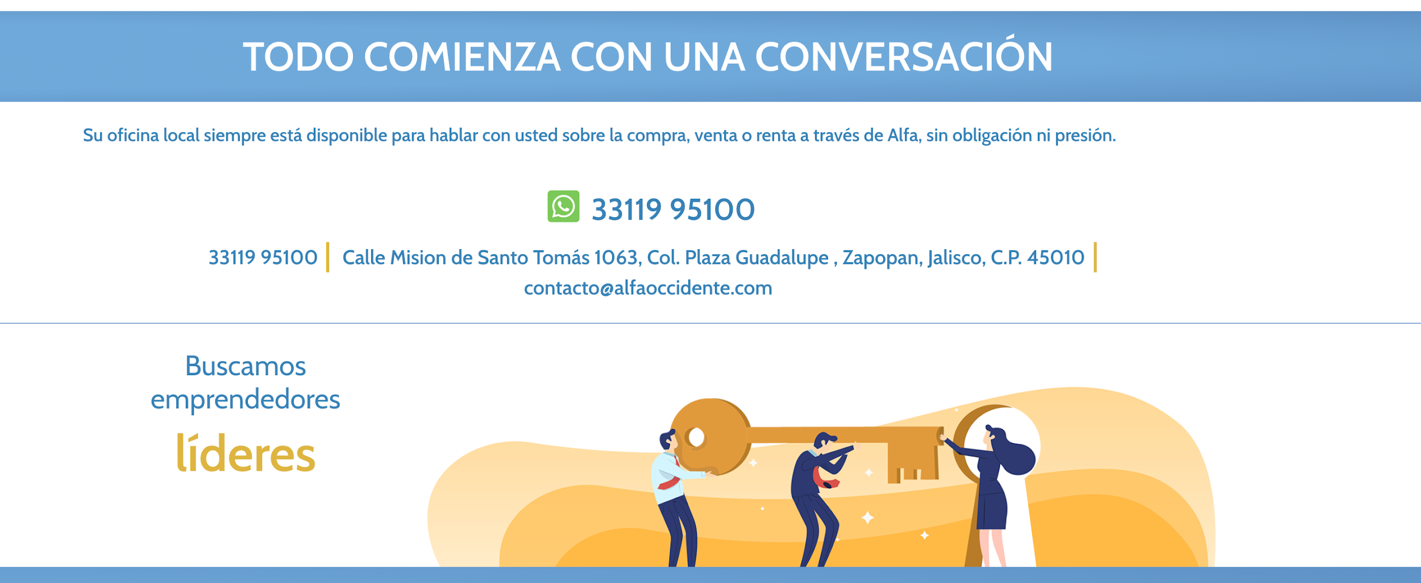

1. **VENDER**

* A catchy copy that Annie and I can come up with PLUS a contact form.

1. **COMPRAR**

* Property list with the highlights, PLUS a filter section at the beginning with the following items: Casa OR Departamento / Rango de precios (TBD) / Código Postal.
* Ideally, the items would show up, with small pins, in a MAP of the city (via Google Maps). Is this possible Kris?

1. **RENTAR**

* Property list with the highlights, PLUS a filter section at the beginning with the following items: Casa OR Departamento / Rango de precios (TBD) / Código Postal.

1. **ADMINISTRACIÓN DE PROPIEDADES**

* A catchy copy that Annie and I can come up with PLUS a contact form / WhatsApp Button.

1. **QUIÉNES SOMOS**

* A catchy copy that Annie and I can come up based on the information to be provided by the client.

1. **CONTACTO**

* A catchy copy that Annie and I can come up with PLUS a contact form / WhatsApp Button.